**CA7 hands on 5-1**

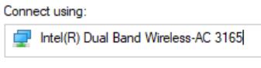

NIC displayed in the “Connect using” text box: **Layer 2 (MAC/Data Link)**

Client for Microsoft Networks: **Layer 5 (Application)**

File and Printer Sharing for Microsoft Networks: **Layer 4 (Transport/TCP/UDP)**

Internet Protocol Version 4: **Layer 3 (Network/IP)**

Internet Protocol Version 6: **Layer 3 (Network/IP)**

